Bo Lin

**ECE 579 Digital Control Systems**

Test 1

Note: Computer generated report is required for the test.

Name: Bo Lin Grade: _____________

Report: (20)

1. (30) (Root Locus) The block diagram shows a simplified form of roll control for an airplane. Overall system specifications with a step input are ts<1.0sec and Mp<30%. Ah is the gain of an amplifier in the H2 feedback loop. G2=A2 is an amplifier of adjustable gain with a maximum value of 100. Restrict *b* to value between 15 and 50.

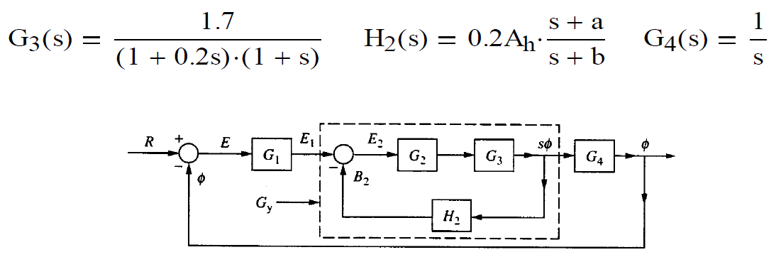

a) With G1(s)=1, determine a set of parameters Ah, a, and b in H2(s) to meet the overall system specifications. Verify your design with simulation (Simulink required, m-file optional). Determine the figures of merit (Mp, tp, and ts) for the overall closed-loop system.

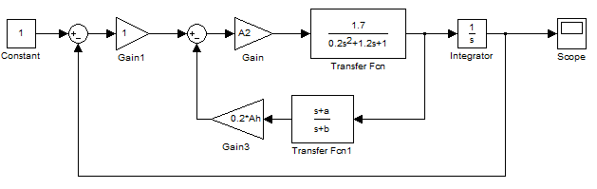

b) With e1(t)=u(t), determine the values of Mp and ts for the inner-loop represented by Gy(s) (Simulink required, m-file optional).

c) With A1=1 (initial value of G1) compute Kv (velocity-error constant).

d) Design G1(s) to increase the value of Kv by a factor of 5 while maintaining the desired overall system specifications.

e) Verify your design of part (d) with simulation (Simulink required, m-file optional). Determine the figures of merit for a step input and compare them with a) (Simulink required, m-file optional).

f) Compare a) and d) for the system performance under ramp input.

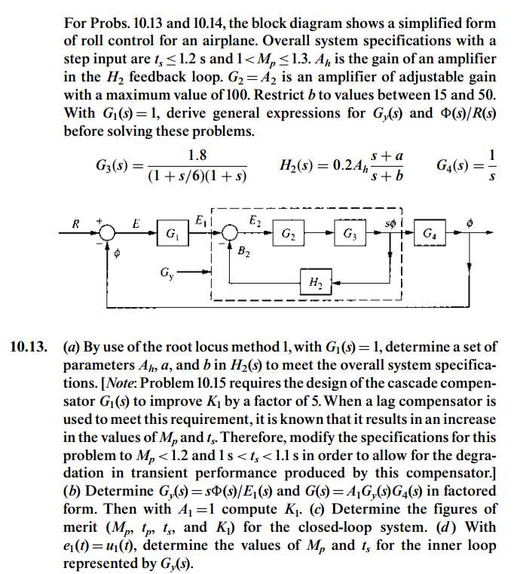

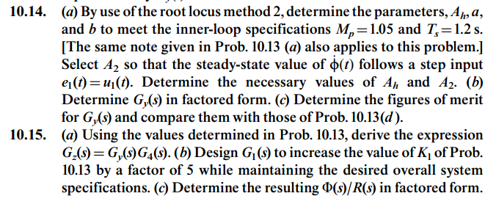



2. (25) (Frequency Response) A basic (uncompensated) control system with unity feedback has a forward open-loop transfer function

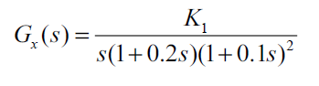

a) For the basic system, find the gain K1 for phase margin PM=45O, and determine the corresponding phase-margin frequency  . Show the step response of the uncompensated system through simulation using Simulink.

b) For the same phase-margin angle as in (a), it is desired to increase phase-margin frequency to a value of =3.0 with maximum possible improvement in gain. To accomplish this, a lead-compensator is used. Determine the value of the lead-compensator that will satisfy these requirements. Determine the new value of gain. Show the step response of the compensated system through simulation using Simulink.

c) Repeat part (b) with a lag-lead compensator. Show the step response of the compensated system through simulation using Simulink.

Show how the compensator has improved the system performance, i.e., determine all figures of merit for each part of the problem.

3. (25) For 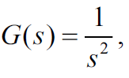

a) design a continuous compensation so that the closed-loop system has a rise time tr<1sec and overshoot Mp<15% to a step input command. Show the step response of the compensated system through simulation using Simulink.

b) revise the compensation so that the specifications would still be met if the feedback was implemented digitally with a sample rate of 5Hz.

c) find difference equations that will implement the compensation in the digital computer.

4. (20) The one-sided z-transform is defined as

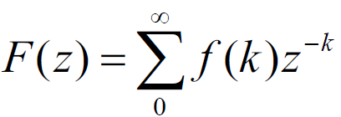

a) Show that the one-sided transform of f(k+1) is Z{f(k+1)}=zF(z)-zf(0).

b) Use the one-sided transform to solve for the transformations of the Fibonacci numbers, Let  .

c) Compute the location of the poles of the transform of the Fibonacci numbers.

d) Compute the inverse transform of the numbers.

e) Show that if uk is the kth Fibonacci numbers, then the ratio uk+1/uk will go to  , the golden ration of the Greeks.

f) Show if we add a forcing term, e(k), to equation  , we can generate the Fibonacci numbers by a system that can be analyzed by the two-sided transform; i.e., let and let  ( at k=0 and zero elsewhere). Take the two sided transform and show the same U(z) results in part (b).